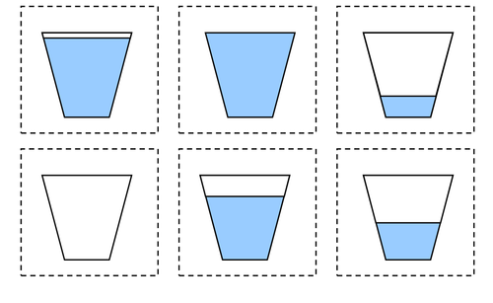
LO: to cut and order the cups from empty to full WC: 11.1.21

