Can you label the picture. W/C 25.1.21

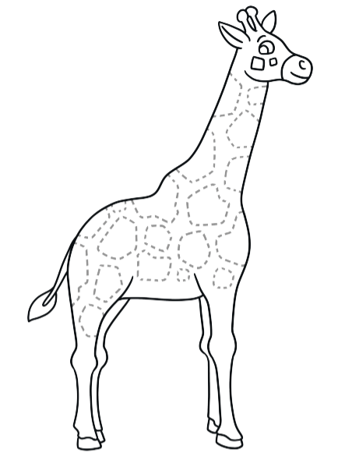

head | leg | neck | back | hoof

