LO: To understand the vocabulary of length. w/c 1.2.21
Please circle the correct answer t the following questions.

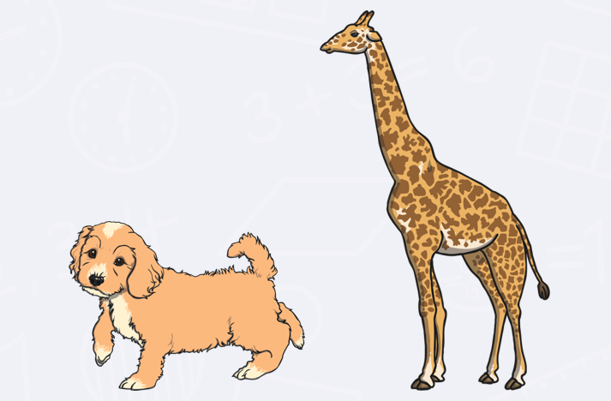
What is the shortest?

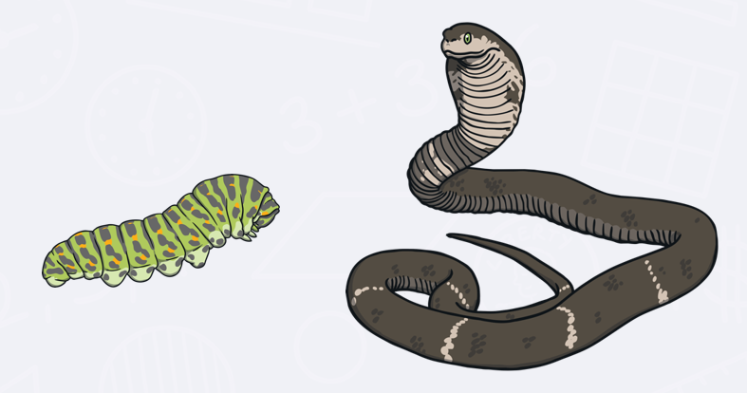
What is the longest?

What is the tallest?

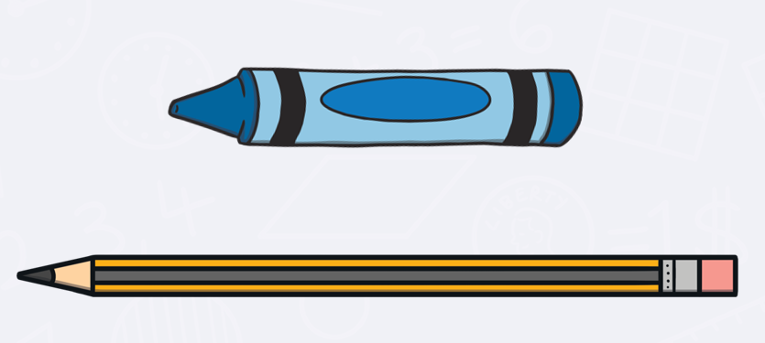
What is the longest?

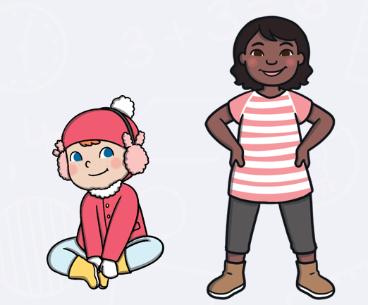
Who is the smallest?

Who is the tallest in your house?

Who has the longest fingers?

Who is the shortest in your house?

