LO: To match the animals facts to the correct animal. w/c 18.1.21

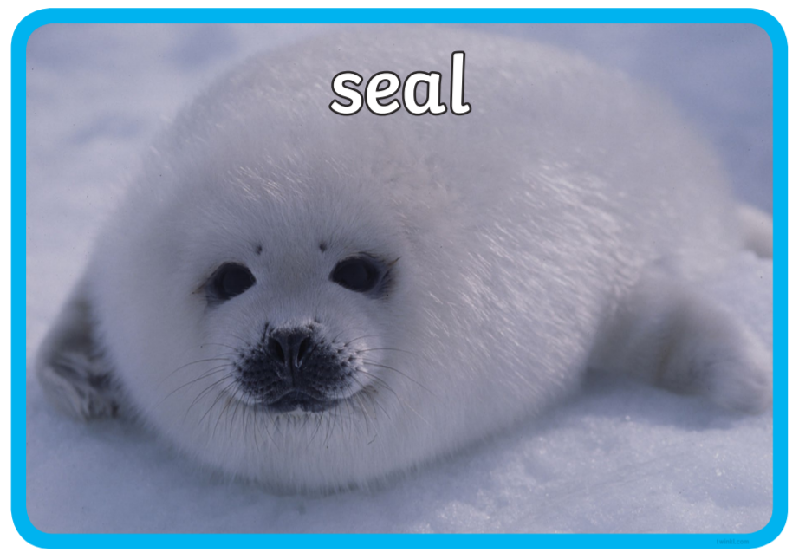 I can fly.

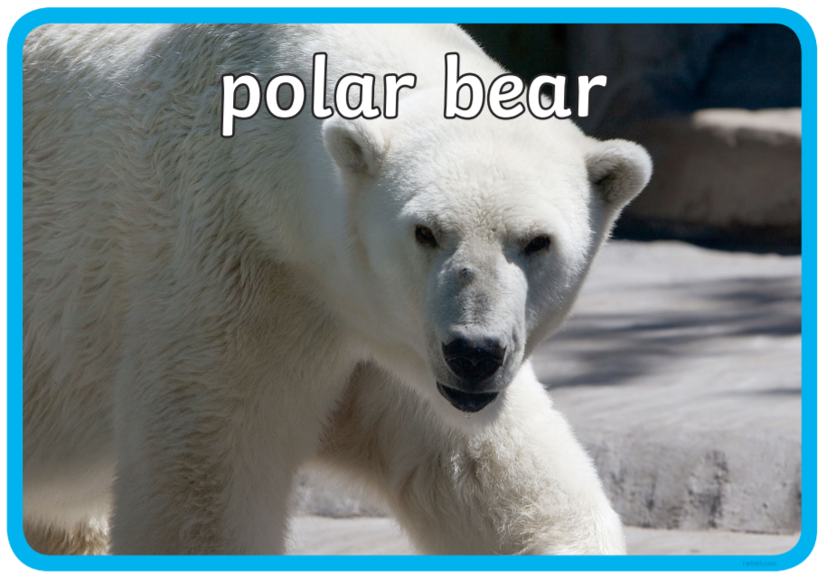 I have wings but I do not fly.

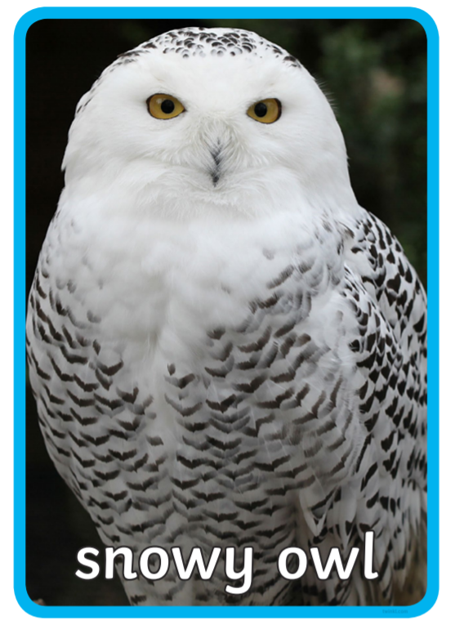 I have got big antlers.

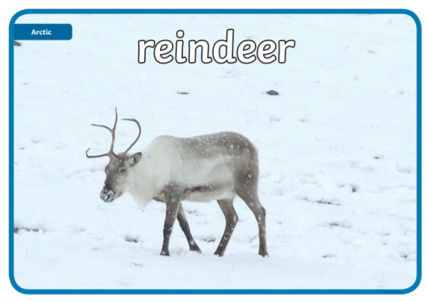 I can swim.

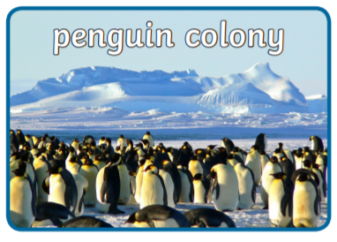 I have white fur.

