LO: To write words with the ‘ai’ digraph. w/c 1.2.21

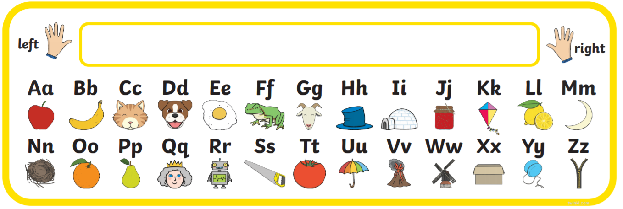

|  |  |  |  |
| --- | --- | --- | --- |
|  | m | ai | l |
|  |  |  |  |
|  |  |  |  |
|  |  |  |  |
|  |  |  |  |