Thursday 28th January 2021
Early morning work

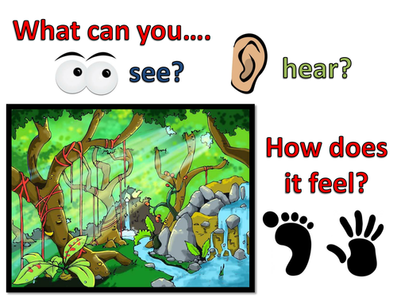
How many adjectives can you think of to describe this picture?

