LO: To write words with the ‘ng’ digraph. w/c 25.1.21

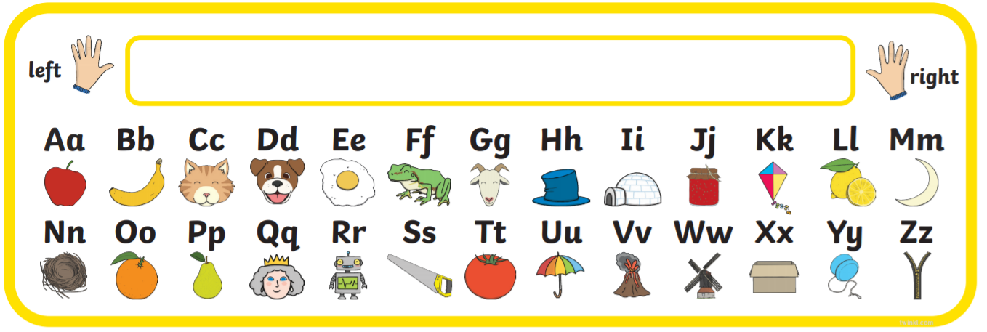

|  |  |  |  |
| --- | --- | --- | --- |
|  | b | a | ng |
|  |  |  |  |
|  |  |  |  |
|  |  |  |  |
|  |  |  |  |