LO: To investigate reversible and irreversible change |  |  | 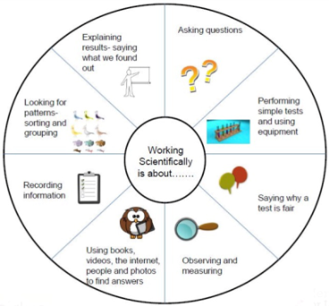
During this lesson we have investigated what happens to different materials when we change them, either by heating, cooling, stretching or bending. Then we looked at whether the change was reversible or irreversible.
Material | Before | After |  | Reversible or irreversible change?
Chocolate
(heat/cool)
Ice
(heat/cool)
Can
(squash/bend)
Plastic bottle
(squash/bend)
Bread
(heat/cool)
Elastic band
(stretch/bend)

